Quiz 2

# Huraira qayyum || 200671

### Lab Computer Networking

## Q1. Complete the following network in Packet Tracer:

### Network 1:

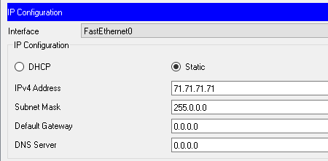

### Network 2:

